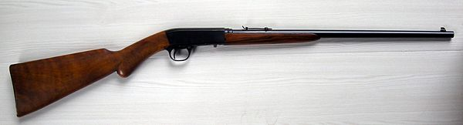

SEPTEMBER 19, 2026

ANNUAL CHARLES “BUB” REYNOLDS “YOUTH” .22 SHOOT
17 YEARS AND UNDER

8 A.M. SIGNUP AT THE EDUCATIONAL BLDG
EVENT STARTS AT 9 A.M.

.22 SHORTS, OPEN SIGHTS ONLY

THIS WILL BE A TRAIL WALK WITH A VARIETY OF TARGETS SUCH AS SPINNERS, KNOCK DOWNS, RINGERS. (SHOOTING STICKS ALLOWED UP TO 12 YRS OLD). AMMUNITION WILL BE SUPPLIED. SAFETY GLASSES MUST BE WORN AND WE CAN SUPPLY THEM ALSO.

THERE WILL BE 3 AGE GROUPS:
1 – 7 YRS
8 – 12 YRS
13 – 17 YRS

A .22 WILL BE AWARDED TO THE FIRST PLACE WINNERS—ONE IN EACH AGE GROUP.

